Module and Position
Home 2
All of our templates are packed with:
- Extensions - These are modules/plugins/component to use on this template.
- Template - This is only the template install file
- Quickstart - This is your main quickstart package, it will help you to rebuild demo.
- Documentation
If this template is not downloaded directly from amazing-templates.com. Please, go to our website and download full template pakage.
This documentation file helps you build your site manualy

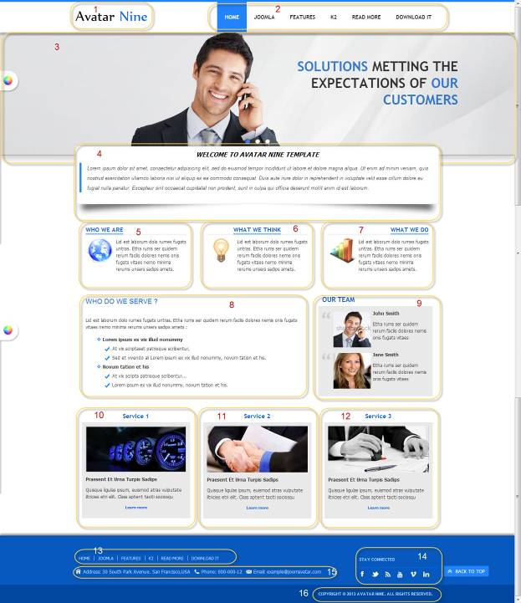

8.
Menu item type: Single Article
Article Name: WHAT DO WE SERVE ?
HTML source code:
<p>Lid est laborum dolo rumes fugats untras. Etha rums ser quidem rerum facilis dolores nemis onis fugats vitaes nemo minima rerums unsers sadips amets :</p>
<ul class="the-cross">
<li><strong><span style="line-height: 1.3em;">Lorem ipsum ex vix illud nonummy</span></strong></li>
<ul class="the-check">
<li><span style="line-height: 1.3em;">At vix scriptaset patrioque scribentur,</span></li>
<li><span style="line-height: 1.3em;">Sed et vivendo ali Lorem ipsum ex vix illud nonummy, novum tation et his. </span></li>
</ul>
<li><strong><span style="line-height: 1.3em;">Novum tation et his</span></strong></li>
<ul class="the-check">
<li><span style="line-height: 1.3em;">At vix scripta patrioque scribentur...</span></li>
<li><span style="line-height: 1.3em;">Lorem ipsum ex vix illud nonummy, novum tation et his. </span></li>
</ul>
</ul>

1.
Module Type: Custom HTML
Module Name: Logo
Module Class Suffix: no-padding-marging avatar-template-logo
Position: Top-left

HTML source code:
<p><a href="Your Link Site "><span style="color: #000;">Your</span> Site Name</a></p>

2.
Module Type: Menu
Module Name: Main Menu
Module class suffix: _menu no-padding-marging
Menu class suffix: avatar-main-menu
Alternative layout: Responsive
Position: Top-right

3.
Module Type: Avatar Articles Nivo
Module Name: Banner Tool Home
Module Class Suffix: avatar-caption no-padding-marging avatar-banner-full
Module Postion: Tool

Go to Content Manager.
Creat New Category.
Create articles in category just created.
In a newly created articles, Select intro image and written content slide.
Then go to the Banner Tool Home Manager.
Select the category for slidershow.

4.
Module Type: Custom HTML
Module Name: Slogan home 2
Module class suffix: avatar-module-2 avatar-slogan-margin-negative no-padding-marging avatar-shadow-1
Position: Content-top

HTML source code:
<p style="text-align: center;"><em><strong style="line-height: 24px; font-size: 16px; color: black;">WELCOME TO AVATAR NINE TEMPLATE</strong></em></p>
<blockquote>
<p style="text-align: left;"><span style="line-height: 24px; font-size: 13px;">Lorem ipsum dolor sit amet, consectetur adipisicing elit, sed do eiusmod tempor incididunt ut labore et dolore magna aliqua. Ut enim ad minim veniam, quis nostrud exercitation ullamco laboris nisi ut aliquip ex ea commodo consequat. Duis aute irure dolor in reprehenderit in voluptate velit esse cillum dolore eu fugiat nulla pariatur. Excepteur sint occaecat cupidatat non proident, sunt in culpa qui officia deserunt mollit anim id est laborum.</span></p>
</blockquote>

5, 6, 7
Module Type: Custom HTML
Module Name: WHO WE ARE, WHAT WE THINK, WHAT WHE DO (Show title)
Module class suffix:
WHO WE ARE : avatar-module-7 avatar-wwa
WHAT WE THINK : avatar-module-7 avatar-heading-center avatar-wwt
WHAT WHE DO : avatar-module-7 avatar-heading-right avatar-wwd
Position: user-8, user-9, user-10

HTML source code:
<p><span style="line-height: 1.3em;">Lid est laborum dolo rumes fugats untras. Etha rums ser quidem rerum facilis dolores nemis onis fugats vitaes nemo minima rerums unsers sadips amets.</span></p>

9.
Module Type: Custom HTML
Module Name: OUR TEAM
Module class suffix: no-padding-margin-side avatar-module-7
Position: right-top

HTML source code:
<p><img src="your image Link" alt="" style="margin-top: 30px; display: block; margin-left: auto; margin-right: auto;" /></p>

7.
Module type: Custom HTML
Module name: LASTEST NEWS (Show title)
Module class suffix: avatar-module-7
Module class suffix: avatar-module-team avatar-module-8
Position: Right-top

HTML source code:
<div class="avatar-team">
<div class="avatar-team-image"><img src="Team 1 image Link" alt="" /></div>
<div class="avatar-team-info">
<p class="avatar-team-name">Team 1 Name</p>
<p>Etha rums ser quidem rerum facilis dolores nemis onis fugats vitaes</p>
</div></div>
<div class="avatar-clear"> </div>
<div class="avatar-team">
<div class="avatar-team-image"><img src=" Team 2 image Link " alt="" /></div>
<div class="avatar-team-info">
<p class="avatar-team-name"> Team 2 Name </p>
<p>Etha rums ser quidem rerum facilis dolores nemis onis fugats vitaes</p>
</div></div>
<div class="avatar-clear"> </div>

10, 11, 12
Module Type: Custom HTML
Module Name: Service 1, Service 2, Service 3 (Show title)
Module class suffix: avatar-module-8 avatar-heading-center
Position: user-5, user-6, user-7

HTML source code:
<p style="text-align: center;"><strong><img src="Your service Image Link" alt="" /></strong></p>
<p><strong>Praesent Et Urna Turpis Sadips</strong></p>
<p>Quisque ligulas ipsum, euismod atras vulputate iltricies etri elit. Class aptent taciti sociosqu</p>
<p style="text-align: center; font-size: 10px;"><a href="Link to service article"><strong>Learn more</strong></a></p>

13.
Module Type: Menu
Module Name: Footer Menu
Module class suffix: no-padding-margin-side
Menu class suffix: avatar-footer-nav
Alternative layout: Responsive
Position: Footer-Left

14.
Module Type: Custom HTML
Module Name: Address
Module Class Suffix: avatar-module-border-top avatar-footer-address no-padding-marging
Position: Footer -left

HTML source code:
<ul style="display: table;">
<li class="avatar-address"><span style="line-height: 1.3em;">Address: Your Address</span></li>
<li class="avatar-phone"><span style="line-height: 1.3em;">Phone: Your Phone Number</span></li>
<li class="avatar-email"><span style="line-height: 1.3em;">Email: Your email</span></li>
</ul>

15.
Module Type: Custom HTML
Module Name: STAY CONNECTED
Module Class Suffix: no-padding-margin-side social-heading
Position: Footer -right
HTML source code:
<div class="avatar-footer-social avatar-module-border-top">
<a class="facebook" href="Your Facebook Link"> </a>
<a class="twitter" href="Your Twitter Link"> </a>
<a class="feed" href="Your Feed Link"> </a>
<a class="youtube" href="Your Youtube Link"> </a>
<a class="vimeo" href="Your Vimeo Link"> </a>
<a class="linkedin" href="Your Linkedin Link"> </a>
</div>

16.
Module Type: Custom HTML
Module Name: copyright
Module Class Suffix: avatar-copyright
Position: Footer

HTML source code:
<p><a href="www.joomavatar.com">Copyright © 2013 Avatar Nine. All Rights Reserved.</a></p>

